The A“Maze”ing Race

Modeling Review

For your assigned group, create a scatterplot with the given data. Decide which model (linear, quadratic, cubic, or exponential) best fits the data. Remember to adjust the size of the WINDOW.

- AMUSEMENT PARK The annual attendance (in hundred thousands) at Brownville Amusement Park over the last 8 years is shown in the table below.

__________________________________

Year | 2004 | 2005 | 2006 | 2007 | 2008 | 2009 | 2010 | 2011
Annual Attendance  (in hundred thousands) | 15.7 | 17.8 | 21.4 | 23.1 | 24.6 | 20.8 | 18.3 | 16.9

- CHARITY The annual donations (in thousands) to Brownville Philanthropy over the last 8 years are shown in the table below.

__________________________________

Year | 2004 | 2005 | 2006 | 2007 | 2008 | 2009 | 2010 | 2011
Annual Donations  (in thousands) | 30.3 | 27.9 | 23.9 | 24.4 | 29.3 | 34.7 | 37.3 | 29.1

- SPORTS The winning times (in minutes) in the women’s 400-meter freestyle swimming event in the Olympics from 1980 to 2008 are shown in the table below.

__________________________________

Olympic Year | 1980 | 1984 | 1988 | 1992 | 1996 | 2000 | 2004 | 2008
Winning Times  (in minutes) | 4.15 | 4.12 | 4.06 | 4.12 | 4.12 | 4.10 | 4.09 | 4.05

- CREDIT CARDS The total credit card volume (in billions) for Visa, MasterCard, American Express, and Discover over an 8-year time period is shown in the table below.

__________________________________

Year | 1990 | 1991 | 1992 | 1993 | 1994 | 1995 | 1996 | 1997
Annual Donations  (in thousands) | 338.4 | 361.0 | 403.1 | 476.7 | 584.8 | 701.2 | 798.3 | 885.2
Purpose

- Determine relationship between the length (number of dots) of the maze and the amount of time needed to complete the maze.

Materials

- stopwatch
- 6 different dot mazes
- pencil or pen
- graphing calculator

Procedures

- Find a buddy.
- Randomly distribute the dot mazes face down.
- Decide which buddy will be “A” and which buddy will be “B”.

When instructed to begin:
- Buddy B: Say “Begin” and start timing.
- Buddy A: Turn over the dot maze and complete the dot maze by connecting the dots in numerical order with your pencil or pen.
- Buddy B: Stop timing with Buddy B connects to the “End” dot.
- Record the times to the nearest tenth of a second on the table below.
- Repeat steps 4 through 7, but switch buddy roles.

Buddy | Number of Dots | Amount of Time  (to the nearest tenth of a second)
A
B

- Send your data to the teacher.
- Using the class data, make a scatterplot of “Number of Dots” versus “Amount of Time”.

Questions

1. Which model (linear, quadratic, cubic, or exponential) best fits the data? Explain your rationale.

_____________________________________________________________________________________

_____________________________________________________________________________________

2. Using the graphing calculator, fit a regression line to examine the relationship between the length of the maze and the time it takes to complete the maze. Write the equation of the line.

_____________________________________________________________________________________

3. What is the average amount of time needed to complete a maze with 50 dots? Show your work.

_____________________________________________________________________________________

_____________________________________________________________________________________

_____________________________________________________________________________________

_____________________________________________________________________________________

4. If it took Sally Sue 90 seconds to complete a dot maze, approximately how many dots were contained within the maze? Show your work.

_____________________________________________________________________________________

_____________________________________________________________________________________

_____________________________________________________________________________________

_____________________________________________________________________________________

5. In one sentence, answer the following question using the above data analysis to support your response. What is the relationship between the length (number of dots) of the maze and the amount of time needed to complete the maze?
_____________________________________________________________________________________

_____________________________________________________________________________________

_____________________________________________________________________________________

_____________________________________________________________________________________

Maze with 15 dots
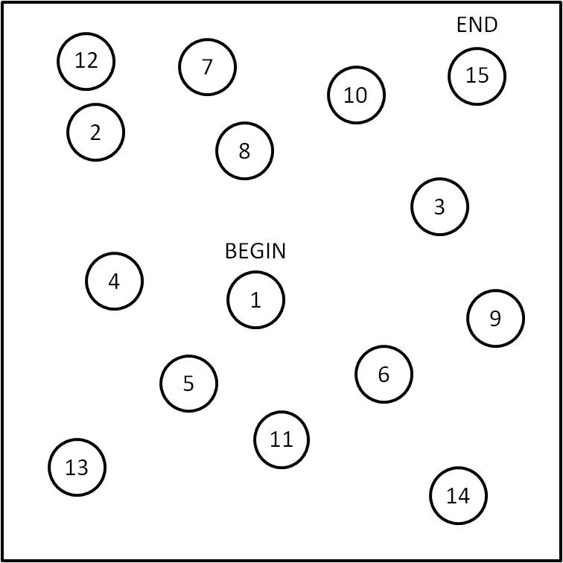
Maze with 16 dots
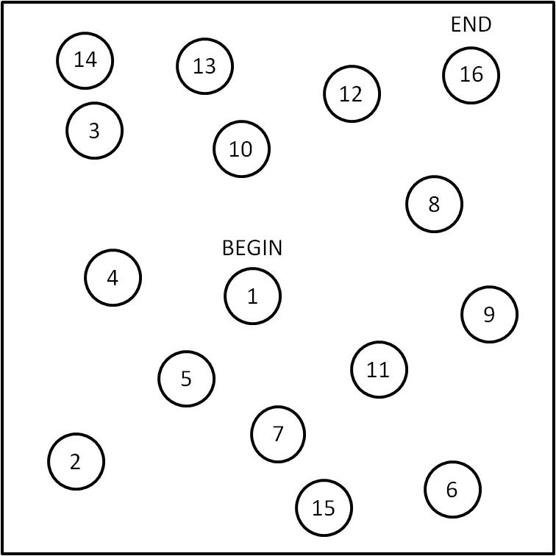
Maze with 17 dots
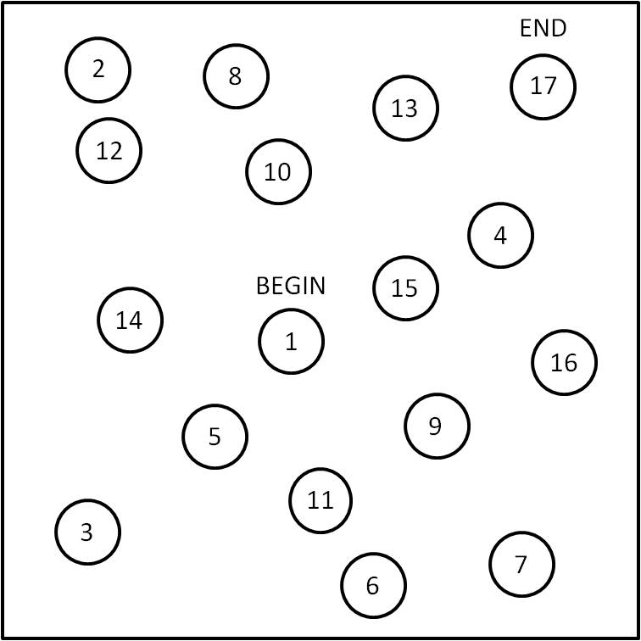
Maze with 18 dots
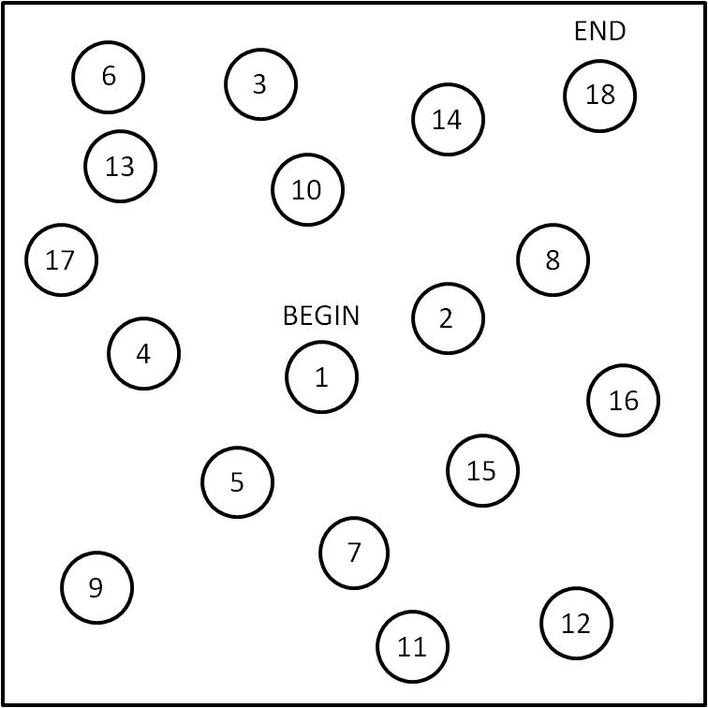
Maze with 19 dots
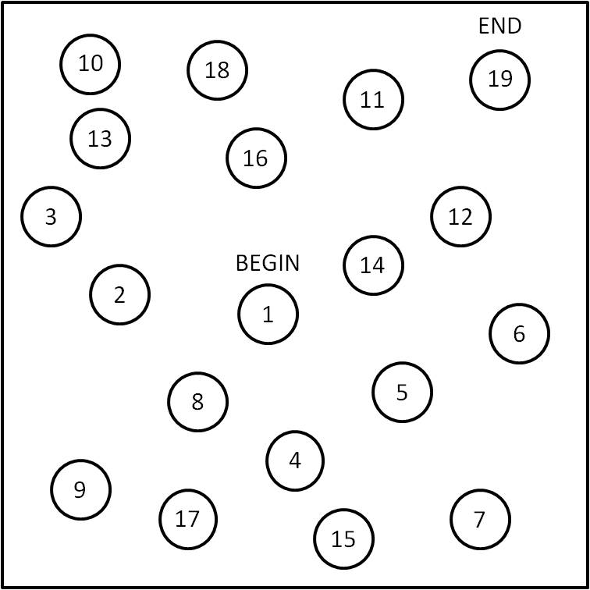
Maze with 20 dots
